|  |  |  |  |  |  |  |  |  |  |  |
| --- | --- | --- | --- | --- | --- | --- | --- | --- | --- | --- |
| **Software Design Specifications**      ***FREEGX***  ***[Freelancing Platform with Project Management]***     |  |  | | --- | --- | | **Project Code** | 4805 | | **Supervisor** | Mr. Ubaid Aftab Chawala | | **Co Supervisor** | Mr. Sayed Yousuf | | **Project Team** | 19k-0218 Saad Ur Rehman  19k-1373 Abdul Shakoor  19k-1499 Muhammad Anas | | **Submission Date** | 25th Nov 2022 | |

**[Instructions]**

- *No section of template should be deleted. You can write ‘Not applicable’ if a section is not applicable to your project. But all sections must exist in the final document.*

- *All comments/examples mentioned in square brackets ([]) are in the template for explanation purposes and must be replaced / removed in final document.*

- *This’ Instruction’ section should also be removed in final document.*

- *MS-Word Reviewing feature must be used to get the document reviewed by PMs or supervisors.*

**Document History**

|  |  |  |  |
| --- | --- | --- | --- |
| Version | Name of Person | Date | Description of change |
| 1 | Saad Ur Rehman | 21th Nov 2022 | Document Created, Build structure of the document, Created table of content and headings. |
| 2 | Abdul Shakoor | 22th Nov 2022 | Added Introduction of the project , Intended Audience, Defining Font Size and scope |
| 3 | Muhammad Anas | 23th Nov 2022 | Add class diagram , data flow diagram |
| 4 | Abdul Shakoor | 24th Nov 2022 | Added few headings , Sequence diagrams and designs consideration. |
| 5 | Muhammad Anas | 24th Nov 2022 | added State diagram |
| 6 | Abdul Shakoor | 25th Nov 2022 | add data dictionary , headings include design  etc , finalize document |

**Distribution List**

|  |  |
| --- | --- |
| **Name** | **Role** |
| Mr. Ubaid Aftab Chawala | Supervisor |
| Mr. Sayed Yousuf | Co Supervisor |
|  |  |

**Document Sign-Off**

|  |  |  |  |  |
| --- | --- | --- | --- | --- |
| **Version** | **Sign-off Authority** | **Project Role** | **Signature** | **Sign-off Date** |
|  |  |  |  |  |
|  |  |  |  |  |

**Document Information**

|  |  |
| --- | --- |
| **Category** | **Information** |
| Customer | FAST-NU |
| Project | FreeGx - Freelancing Platform with Project Management |
| Document | Software Design Specification |
| Document Version | 1.0 |
| Status | Draft |
| Author(s) | Saad Ur Rehman, Abdul Shakoor , Muhammad Anas |
| Approver(s) | Mr. Ubaid Aftab Chawala , Mr. Sayed Yousuf |
| Issue Date |  |
| Document Location | Karachi |
| Distribution | Advisor  Project Coordinator’s Office (through Advisor) |

**Definition of Terms, Acronyms and Abbreviations**

|  |  |
| --- | --- |
| **Term** | **Description** |
| ASP | Active Server Pages |
| DD | Design Specification |
| FYP | Final Year Project |
| WBS | Work breakdown structure |
|  |  |
|  |  |
|  |  |
|  |  |

**Table of Contents**

**1 Introduction** **7**

*1.1 Purpose of Document* *7*

1.2 Intended Audience 7

1.3 Document Convention 7

1.4 Project Overview 7

1.5 Scope 7

**2 Design Considerations** **8**

2.1 Assumptions and Dependencies 8

2.2 Risks and Volatile Areas 8

**3 System Architecture** **8**

3.1 System Level Architecture 9

3.2 Software Architecture 10

**4 Design Strategy** **10**

**5 Detailed System Design** **11**

5.1 Database Design 11

5.1.1 ER Diagram 12

5.1.2 Data Dictionary 12

5.1.2.1 Data 1 12

5.1.2.2 Data 2 12

5.1.2.3 Data n 12

*5.2 Application Design* *14*

5.2.1 Sequence Diagram 14

5.2.1.1 <Sequence Diagram 1> 14

5.2.1.2 <Sequence Diagram 2> 14

5.2.1.3 <Sequence Diagram n> 14

5.2.2 State Diagram 14

5.2.2.1 <State Diagram 1> 14

5.2.2.2 <State Diagram 2> 14

5.2.2.3 <State Diagram n> 14

**6 References** **15**

**7 Appendices** **16**

# Introduction

## Purpose of Document

The purpose of this document is to provide understanding of working of FreeGx by giving system designs and modelling. This document will provide knowledge of each and every feature which will available in the final product. This document will also help to transfer the knowledge of freegx to its reader. This document will the work which we will implement in our final product. The Type of designs would be Object oriented designs because all design will have different stakeholders and how they are interacting with real world entities.

## Intended Audience

The target audience is the whole group of peoples who wants to acquire services from providers. The second target group is peoples whose occupation is freelancing. The last clientry is peoples who wanted to join any service providers.

## Document Convention

The font size which will be enough for anyone to be able to read is **10px** with font family is **Aerial** . For Headings the size is **14px** with bold weight.

## Project Overview

FreeGx is a web application where you can do freelancing with ease and search for sellers with extraordinary gigs to provide you with the best quality experience. Through this platform, Seller can add co-workers who will work along with the team lead which increases interpersonal and group-working skills. The seller can share the work breakdown structure with the co-workers so that they will get a clear idea of relevant tasks to perform. The seller can also share progress reports and documents with clients. There will be other features to address previous problems in freelancing platforms.

## Scope

**DELIVERABLES:** The Project contains an introductory website which will be self explanatory and helpful for newly arrived users. There will be three stackholders. The deliverable of seller will be provided services to the client. The client can chat and share files by viewing list of all the services. The project assigned to the seller who will breaks down the project into several tasks and these tasks will be assigned to the associated Coworkers. There will be proper dashboard for each indivitual. The client can ask for the project status and report at any instance from the seller After getting services, The billing module will be used for payment procedures. Lastly, The review will be sended by client.

**FUTURE WORK:** The project will not contains online meeting options and bidding system. The client will approach to seller instead of seller bids on clients post.

**FEASIBILITY:**  The Time constraint allocated for this project is almost 12 months. There will be two deliverables in FYP1 and FYP2. The FYP1 will contains seller portal implementation while FYP2 will contains complete software. At the time being, There is not any cost for project development but may be the project needed some paid resources and services.

# Design Considerations

There were several considerations which need to be considered during design phase. The first consideration would be to map requirement analysis to the design. Align business objectives precisely and within the scope. It is to be considered that each role need to be proper explanatory with only focus areas. We need to make sure that is design should not be over designed. For all these consideration we find assumptions and risks which are mentioned below

## Assumptions and Dependencies

There were numerous issues found during designing phase. To illustrate, we need to make sure that the ER diagrams covers all the tables and there dependencies with type of relation. A single addition or reduction of relation can make drastical changes in the database and can be lead till deployment. Other issues finded in sequence diagram. For sequence diagram. The challenges founded to get rid of additional dependencies and details. Avoid unnecessary details. The highest issue to align all the diagrams related to product.

## Risks and Volatile Areas

During designing phase, The changes in business requirements may lead to changes in designs. Thus, produced extra work on designer. The other may also occurs in our mind during design is to constantly satisfying client requirements.The designs that are fundamentally flawed, infeasible, inefficient, unstable or below client standards can leads to failure in design. For cater these problems. we made buffers , spaces , allowing additional requirements portion so when any update occurs these places can filful the requirement with no advance modifications. For instants, If the client is associated with seller and requirement changes to client is associated with seller aswell as co-worker so in ER diagram. The allowed space for client which used connect with client . Now , The new entity will be introduced named “coworker” which will connect with client. Thats how all the new business requirements frequently changes in design.

# System Architecture

## System Level Architecture

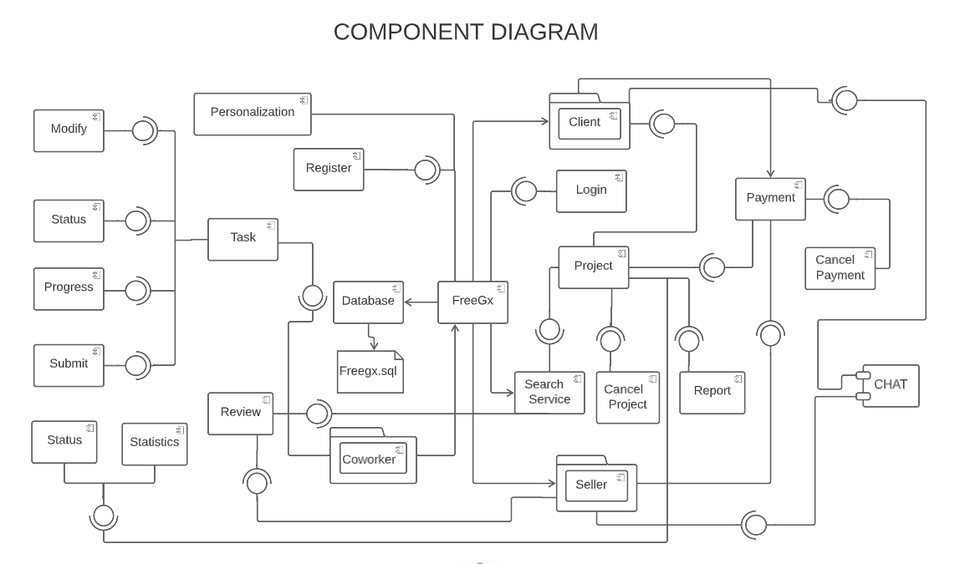

## Software Architecture

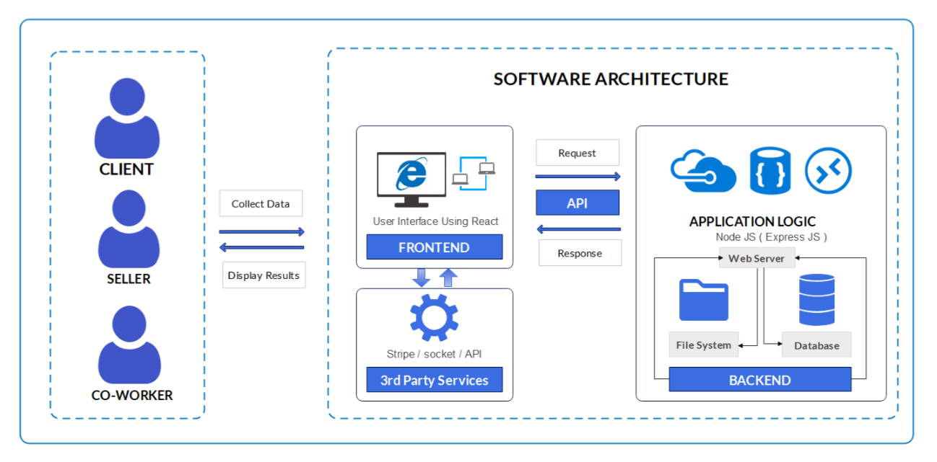

# Design Strategy

The aim of our project design is to create useful , credible, flexible and desirable solution. The goal is to make end goal the most effective for this we use traditional approaches to align the design into business needs. As designers, our objective is clear, we need to absorb all the information at hand from our clients, have a complete understanding of the objective and goal and be able to bridge the gap between creative solution thinking and the intended purpose of the business strategy. The result: a better and custom defined design that communicates a clear message to the specific audience we want to reach.

The mechanisms used during the development of of software architectures are follows

1. REVIEW – What are the design’s measurable goals and objectives?
2. SCAN – What internal and external factors impact the design?
3. FORM – How will the design work to meet these challenges and opportunities?
4. IMPLEMENT – What exactly will we do? Who exactly will do it? How will it be done?
5. EVALUATE – How well does the design achieve its goals and objectives?
6. MAINTAIN – Do we need adjustments or do we keep the design as it is?

The above mechanism help us out to figure that the design will be reusable with low redundancy. The mechanisms helps us differentiate all the control layers and components and how the stakeholder will interact with database. The functional requirements also considered and determines where parallel work can be done where storage is limited. where we need persistence. The answer of all get by using our design strategy.

# Detailed System Design

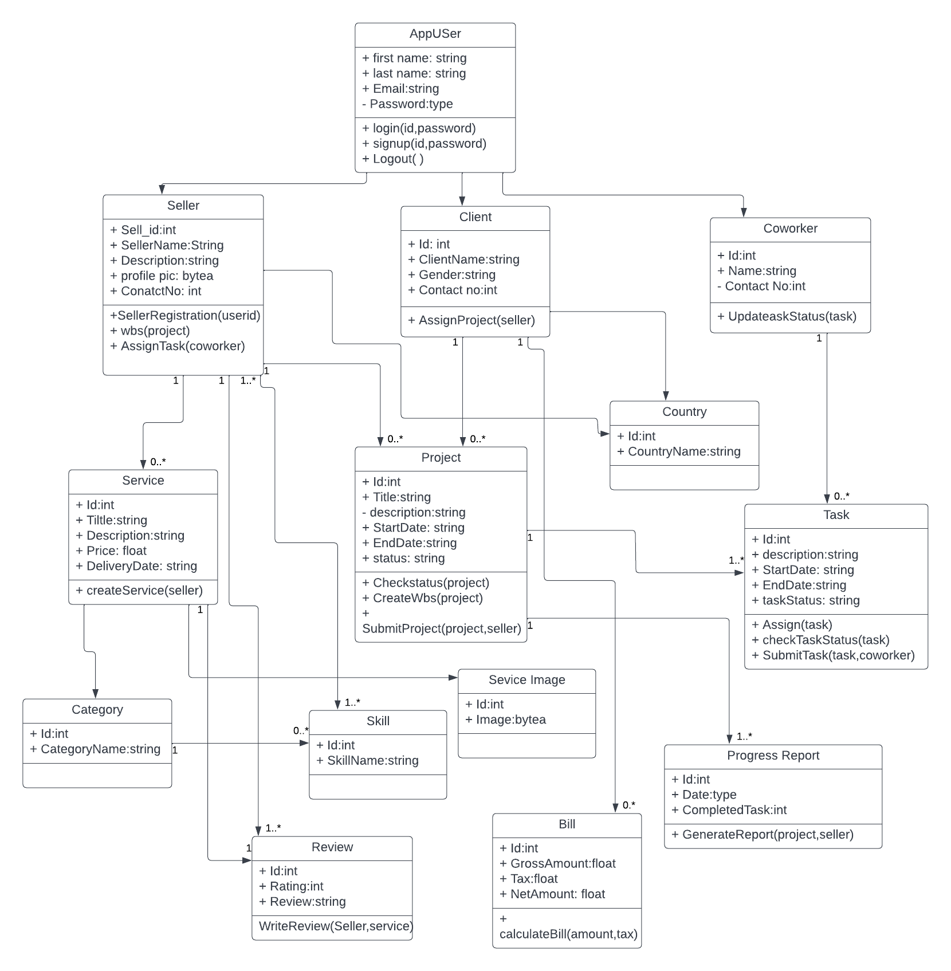

## Database Design

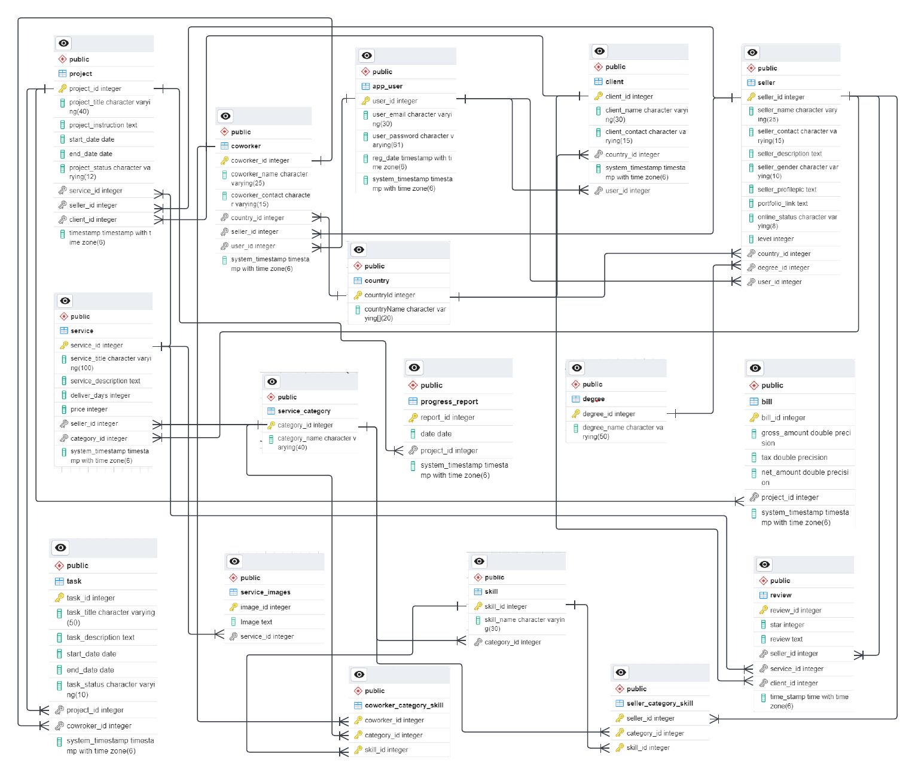

### ER Diagram

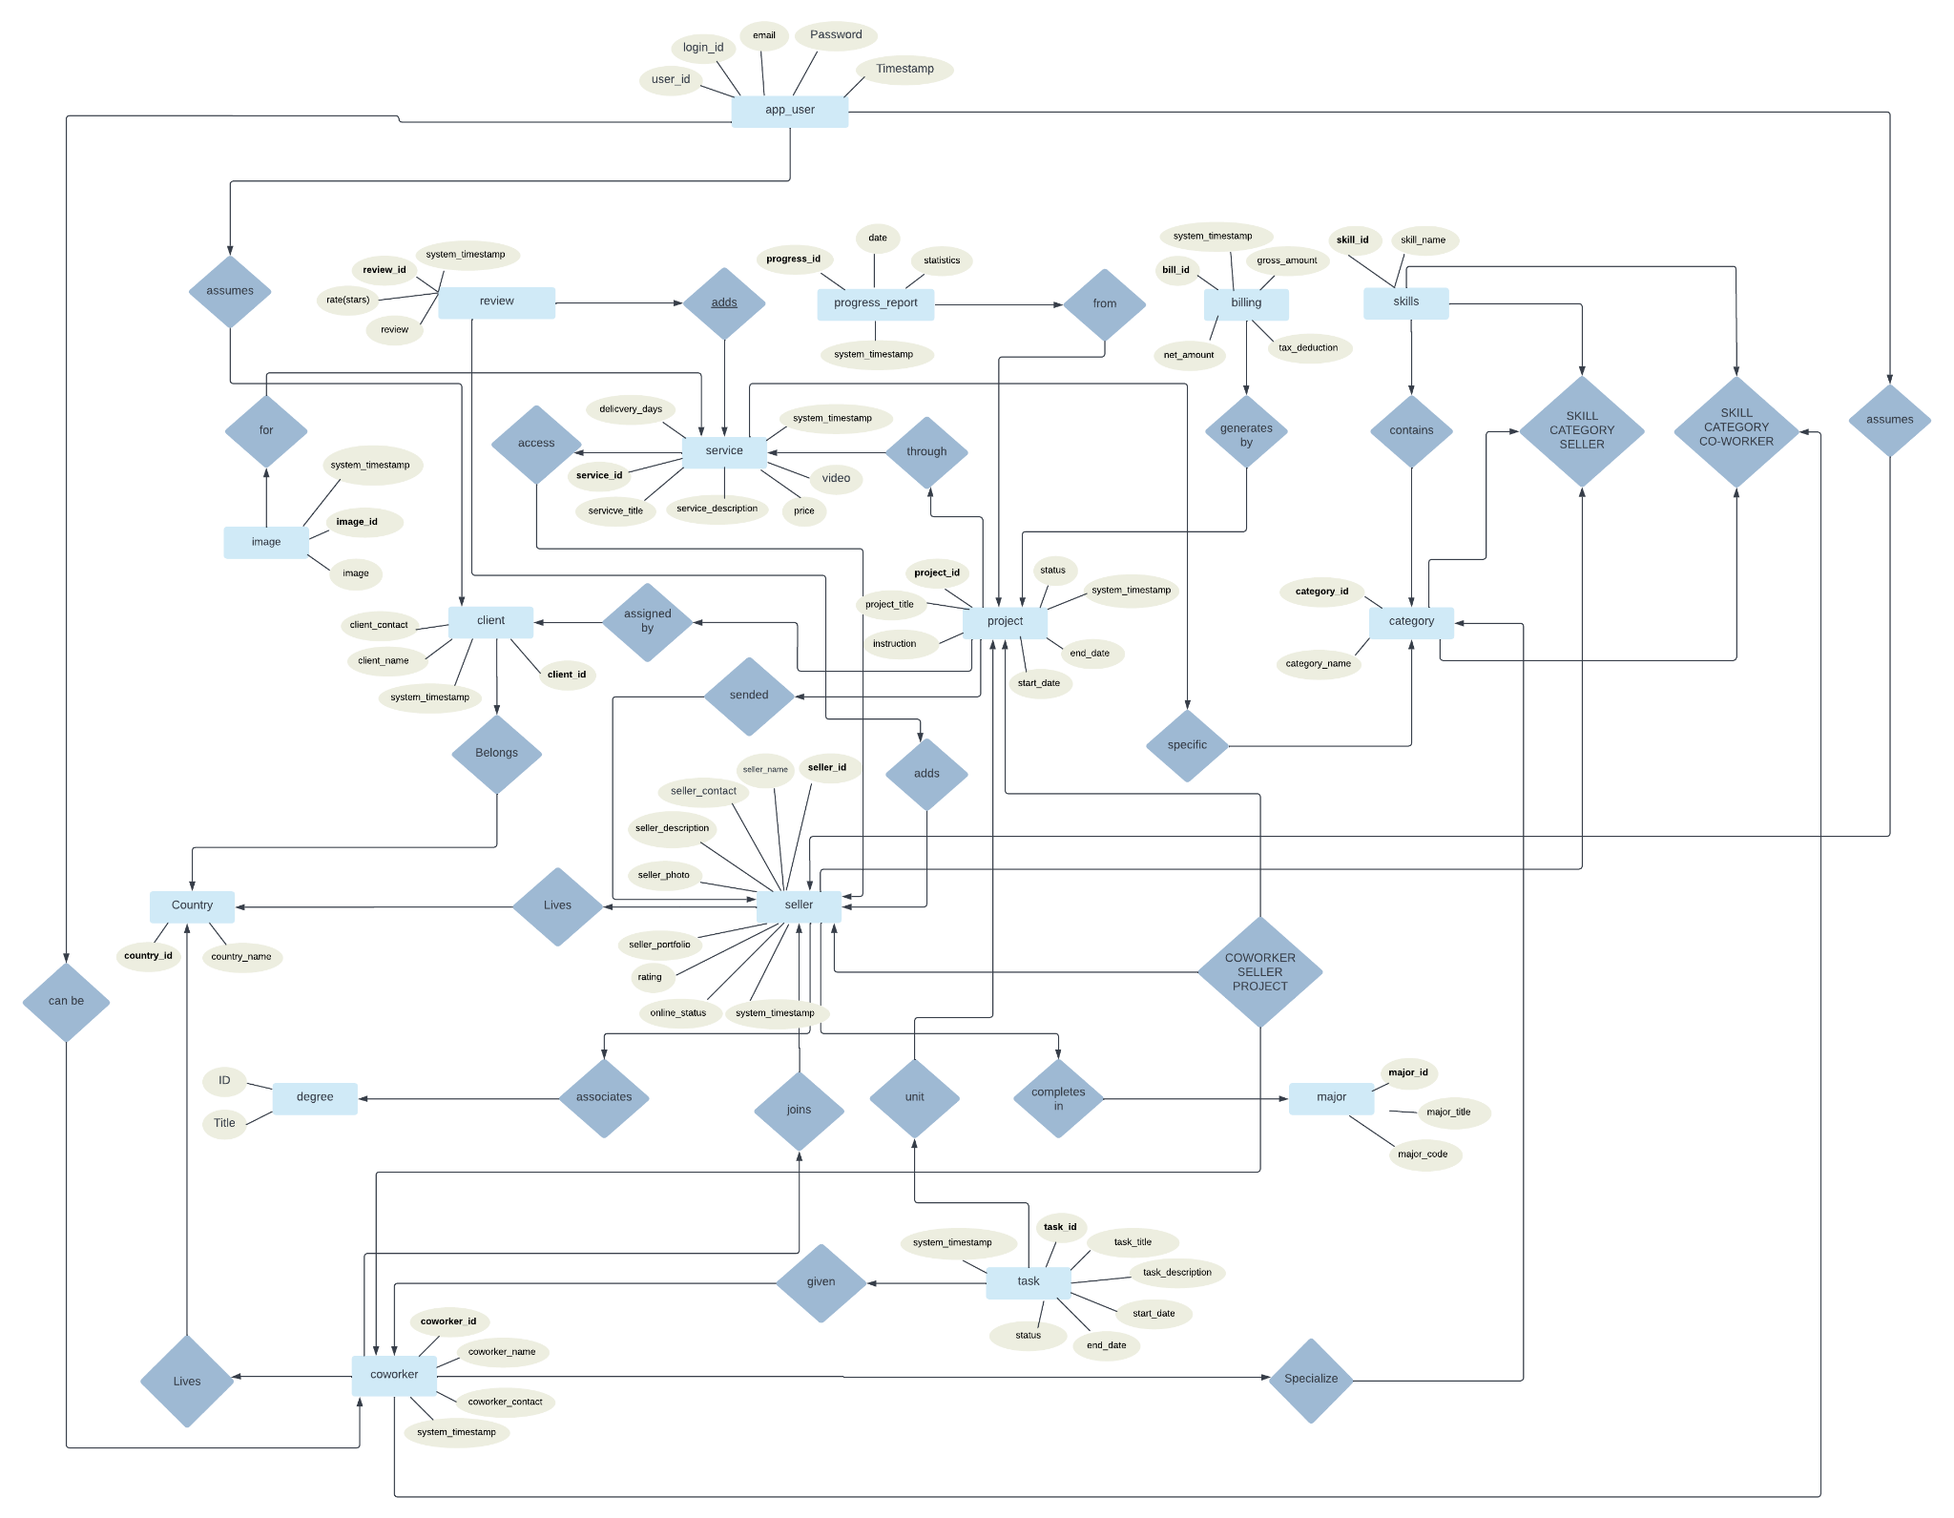

### Data Dictionary

#### Data 1

|  |  |  |  |  |  |  |  |
| --- | --- | --- | --- | --- | --- | --- | --- |
| **Seller** | | | | | | | |
| **Name** | | Seller | | | | | |
| **Alias** | | seller | | | | | |
| **Where-used/how-used** | | coworker , project , country , degree , service , review , project | | | | | |
| **Content description** | | The seller contains all the required details of service provider | | | | | |
| **Column Name** | **Description** | | **Type** | **Length** | **Null able** | **Default Value** | **Key Type** |
| seller_id | This column will be the identity of seller | | integer |  | Not Null |  | PK |
| seller_name | This attribute will store name of seller | | char | 25 | Null |  |  |
| seller_description | This stores the intro and bio of the seller | | char | 15 | Null |  |  |
| seller_gender | This column specify gender of seler | | char | 10 | Null |  |  |
| seller_pic | This will store image in encoded binary form | | byte |  | Null | demo image |  |
| seller_portfolio_url | This will be store url of seller | | text |  | Null |  |  |
| seller_level | It stores the lebel of working | | integer |  | Not Null | 1 |  |
| country_id | It stores the country id of seller | | integer |  | Null |  | FK |
| degree_id | It store the degree id of seller | | integer |  | Null |  | FK |
| user_id | It determines for the role = seller | | integer |  | Null |  | FK |

#### Data 2

|  |  |  |  |  |  |  |  |
| --- | --- | --- | --- | --- | --- | --- | --- |
| **Client** | | | | | | | |
| **Name** | | Client | | | | | |
| **Alias** | | client | | | | | |
| **Where-used/how-used** | | user , country , project , review , seller | | | | | |
| **Content description** | | The client entity contains all the required details of service purchase | | | | | |
| **Column Name** | **Description** | | **Type** | **Length** | **Null able** | **Default Value** | **Key Type** |
| client_id | This column will be the identity of client | | integer |  | Not Null |  | PK |
| client_name | This attribute will store name of client | | char | 30 | Null |  |  |
| client_contact | This stores the intro and bio of the client | | char | 15 | Null |  |  |
| Timestamp | This is for the system timestamp for particular zone | | Date |  | Not Null | sysdate |  |
| country_id | It stores the country id of client | | integer |  | Null |  | FK |
| user_id | It determines for the role = client | | integer |  | Null |  | FK |

#### Data 3

|  |  |  |  |  |  |  |  |
| --- | --- | --- | --- | --- | --- | --- | --- |
| **Coworker** | | | | | | | |
| **Name** | | Coworker | | | | | |
| **Alias** | | coworker | | | | | |
| **Where-used/how-used** | | user , country , task , seller | | | | | |
| **Content description** | | This table contains all information of coworkers associated with sellers | | | | | |
| **Column Name** | **Description** | | **Type** | **Length** | **Null able** | **Default Value** | **Key Type** |
| coworker_id | This column will be the identity of coworker | | integer |  | Not Null |  | PK |
| coworker_name | This attribute will store name of coworker | | char | 25 | Null |  |  |
| coworker_contact | This stores the intro and bio of the coworker | | char | 15 | Null |  |  |
| Timestamp | This is for the system timestamp for particular zone | | Date |  | Not Null | sysdate |  |
| country_id | It stores the country id of client | | integer |  | Null |  | FK |
| user_id | It determines for the role = client | | integer |  | Null |  | FK |
| seller_id | It determines the coworker is associated with which seller | | integer |  | Null |  | FK |

#### Data 4

|  |  |  |  |  |  |  |  |
| --- | --- | --- | --- | --- | --- | --- | --- |
| **Project** | | | | | | | |
| **Name** | | Project | | | | | |
| **Alias** | | project | | | | | |
| **Where-used/how-used** | | client , seller , service , category | | | | | |
| **Content description** | | This table will contains all the projects provided by the client to the seller | | | | | |
| **Column Name** | **Description** | | **Type** | **Length** | **Null able** | **Default Value** | **Key Type** |
| project_id | This column will be the identity of project | | integer |  | Not Null |  | PK |
| project_name | This attribute will store name of project | | char | 40 | Null |  |  |
| project_description | This stores the intro and bio of the project | | text |  | Null |  |  |
| start_data | This attribute contains start date of the assigned project | | Date |  | Not Null | sysdate |  |
| end_data | This attribute contains date of delivery of the assigned project | | Date |  | Not Null |  |  |
| Timestamp | This is for the system timestamp for particular zone | | Date |  | Not Null | sysdate |  |
| service_id | It stores which service generates this project | | integer |  | Null |  | FK |
| client_id | It determines for the role = client | | integer |  | Null |  | FK |
| seller_id | It determines the coworker is associated with which seller | | integer |  | Null |  | FK |

## Application Design

### Sequence Diagram

#### Sequence Diagram 1 ( SELLER )

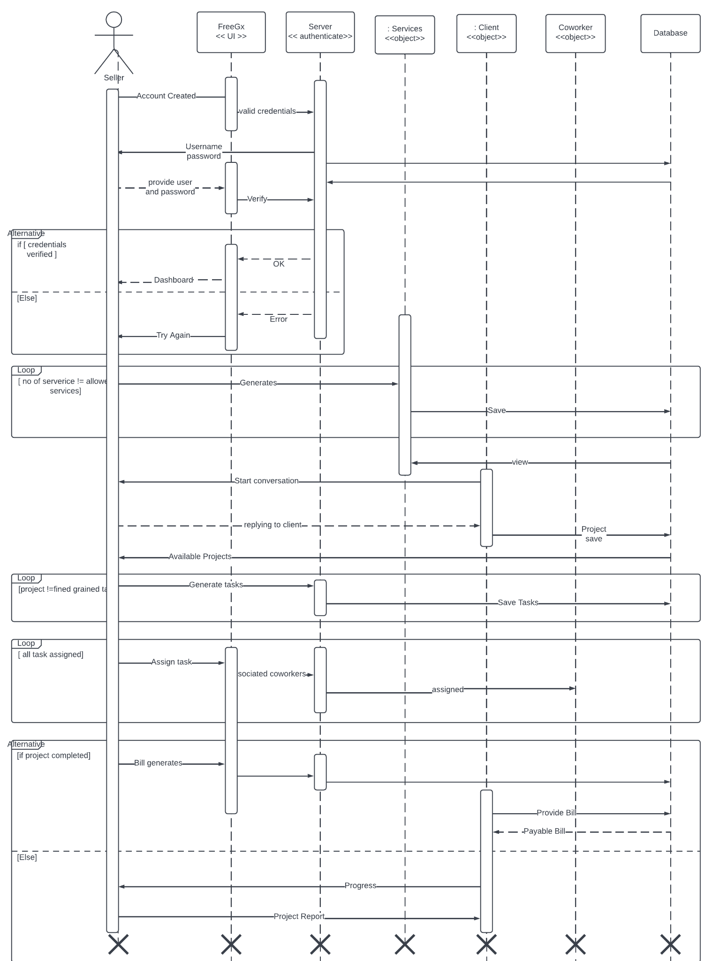

#### Sequence Diagram 2 ( CLIENT)

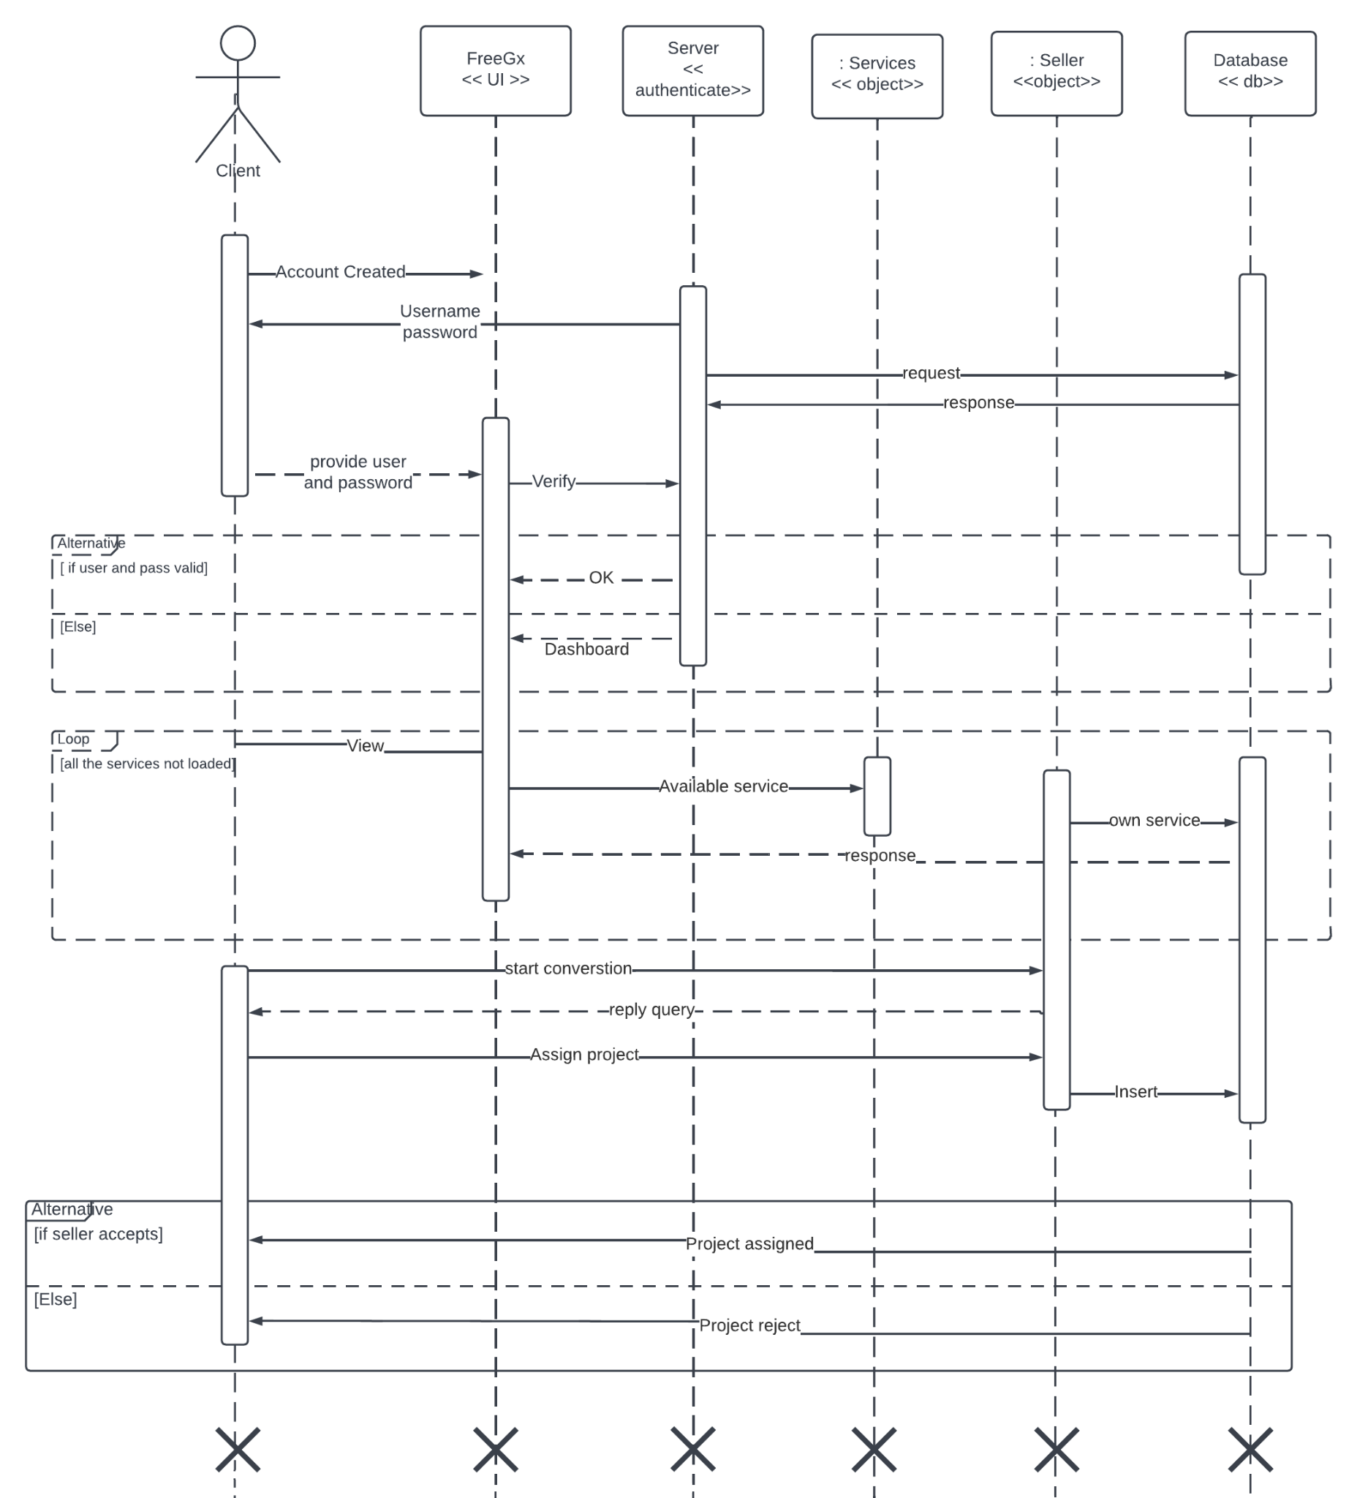

#### Sequence Diagram 3 ( COWORKER )

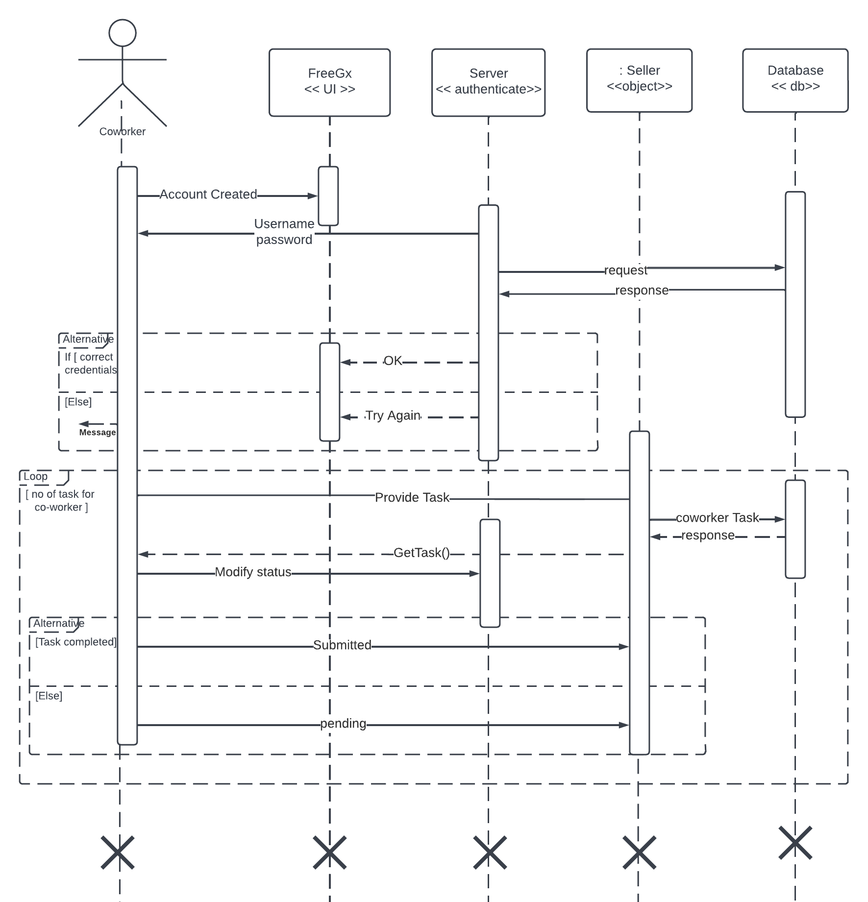

### State Diagram

#### State Diagram 1 (Seller)

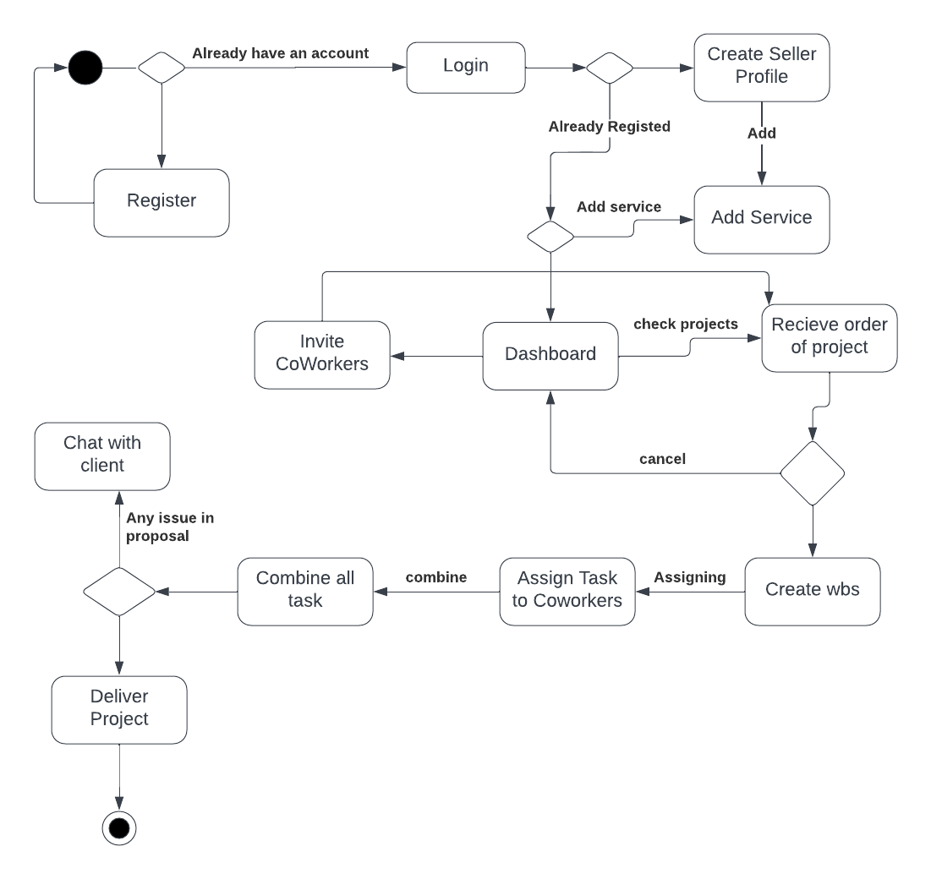

#### State Diagram 2 (Client)

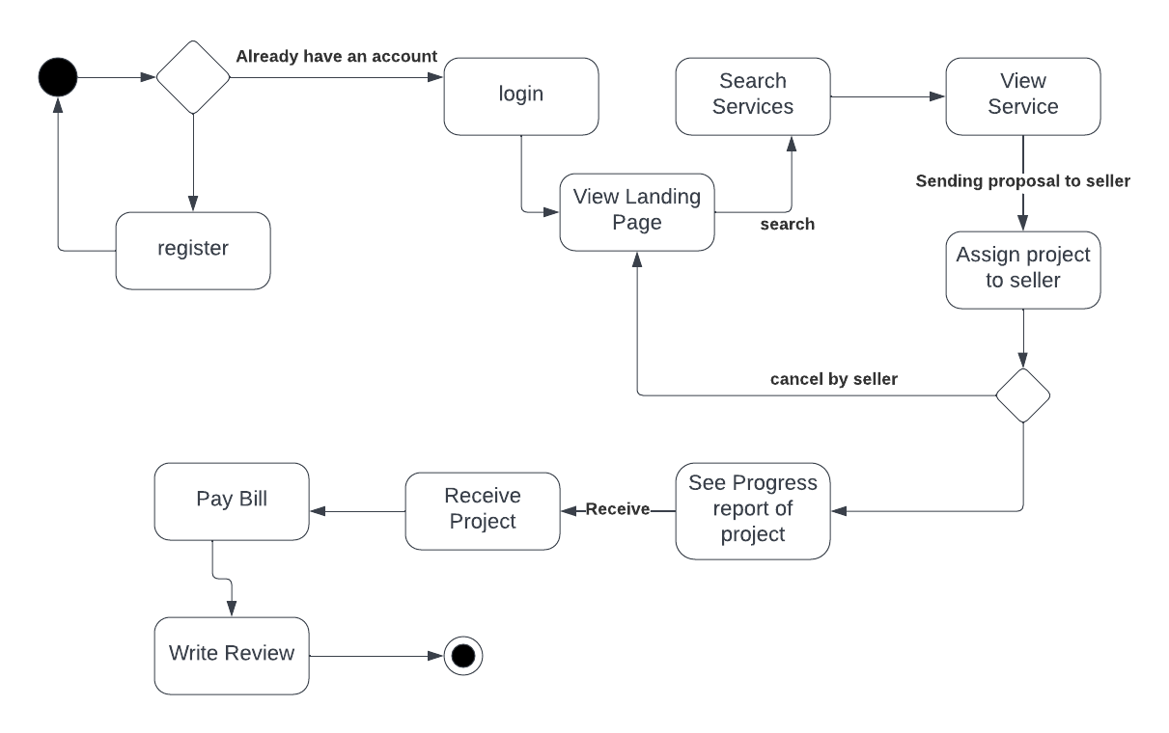

#### State Diagram 3 (Coworker)

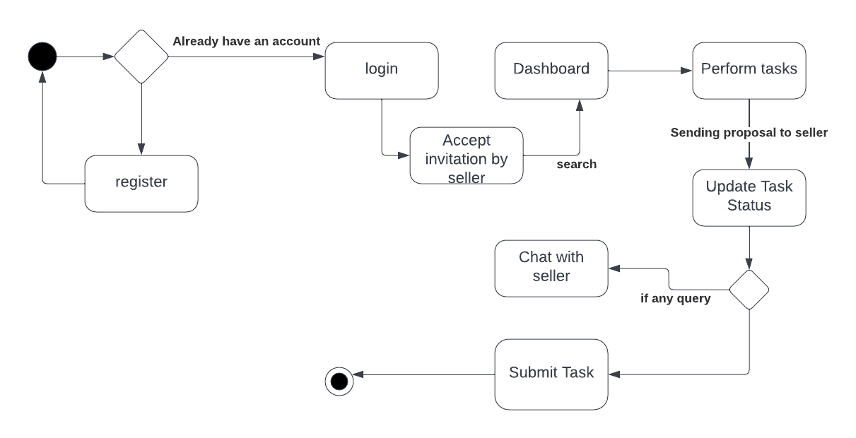

### Data Flow Diagram

# 

**APPENDICS AND BIBLIOGRAPHY NOT APPLICABLE**